Macally USB Wired Mouse with 3 Button

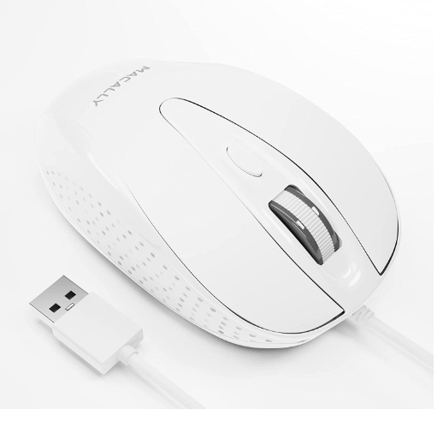

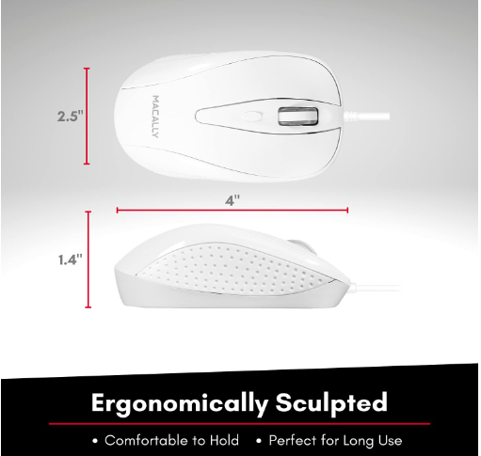

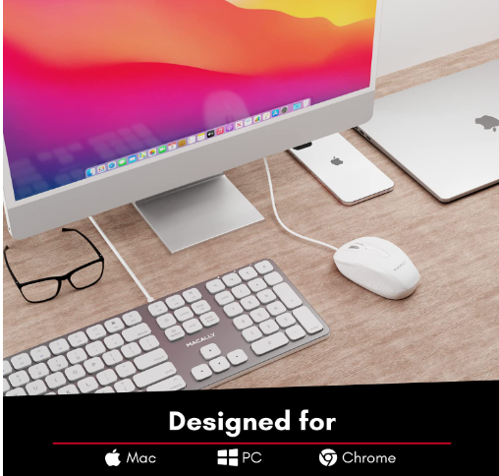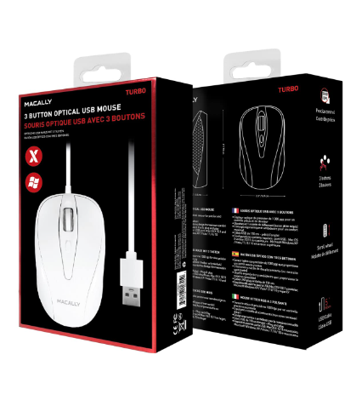

43% ₹3,157

M.R.P.: ₹5,499

Inclusive of all taxes

### Product details

|  |  |
| --- | --- |
| Brand | Macally |
| Connector Type | USB |
| Special Feature | Wired, Optical |
| Movement Detection Technology | Optical |
| Number of Buttons | 3 |
| Compatible Devices | Personal Computer |

* Wired
* Optical